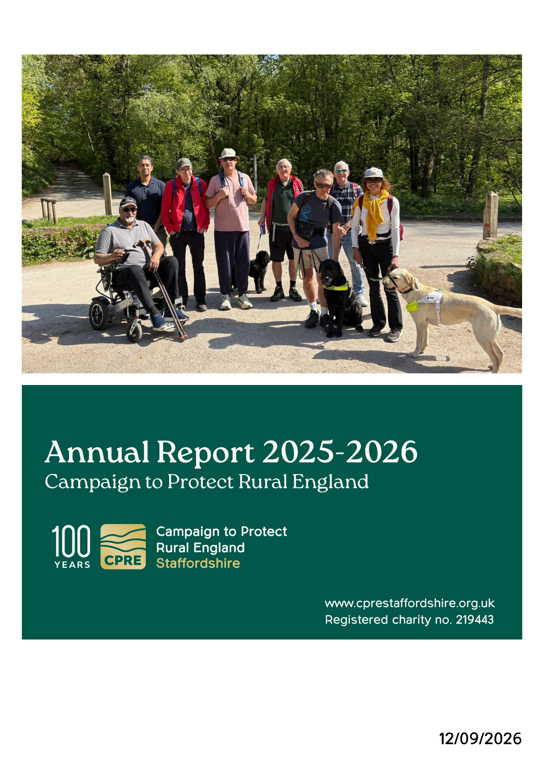

CHAIR’S REPORT AND REVIEW OF THE YEAR

Having taken the reins as Chair this year, I am pleased that the transition has been so smooth. I am particularly grateful to Mohammed, former chairman, for his ongoing support, and to our trustees, volunteers, members and partners whose time, knowledge and enthusiasm make our work possible.
This has been a landmark year, marking both the 90th anniversary of CPRE Staffordshire and the centenary of national CPRE. These milestones give us an opportunity to celebrate a proud history of protecting the countryside while looking ahead to the challenges and opportunities that will shape its future.
Throughout the year, we have continued to help people experience, appreciate, and care for Staffordshire’s countryside. Our Accessibility Walk Series has encouraged more people to enjoy our rural landscapes, while our Dark Skies work has promoted the importance of protecting tranquillity, wildlife and our view of the night sky.
Through the Green Schools Trophy, we have engaged and inspired younger generations, and our litter-picking activities have brought people together to improve their local environment. Countryside on Camera has celebrated Staffordshire’s landscapes through the eyes of those who live in and visit them, while our continued involvement in the Best Kept Village Community Competition has recognised the pride, commitment and community spirit found across the county.
As we look towards 2027, our strategy will focus on three important priorities. We will respond constructively to the challenges presented by the emerging “grey belt” agenda, ensuring that development decisions properly recognise the value of Staffordshire’s countryside and are supported by appropriate infrastructure.
Aligned with CPRE’s On the Edge campaign, we will also champion urban biodiversity projects that bring nature closer to where people live, strengthening the connection between our towns and countryside. Finally, we will review the barriers affecting rural transport and explore a pilot project aimed at improving connectivity, reducing isolation and helping people access employment, education and essential services.
Our role remains as important as ever: to protect Staffordshire’s countryside, promote its value and help shape a sustainable future in which communities and nature can thrive together.
Please do get in touch if you would like to support our work, help plan an event or suggest how we can better promote, protect and enhance Staffordshire’s countryside. We would be delighted to hear from you.
Best wishes,
Sarah Cooke
Chair, CPRE Staffordshire

In Memoriam
It is with great sadness that we remember our trustee and friend, Steve Hopkins, who sadly passed away in August.
Steve was a dedicated and hardworking member of our board, with a deep passion for CPRE Staffordshire and a genuine commitment to protecting and enhancing the countryside.
He brought enthusiasm, knowledge and a sense of community to his role and was always willing to give his time and energy to support our work.
We are grateful for the contribution Steve made to CPRE and the many ways in which he championed the countryside and his local community. He will be greatly missed by the team at CPRE Staffordshire and those who had the pleasure of working with him.
We extend our heartfelt condolences to his friends and family and remember him with great appreciation and affection.

Financial Report
I have pleasure in presenting our receipts and payments account for the year 1 April 2025 to 31 March 2026.

2026 is an important year for CPRE, both Nationally and locally. It is the centenary year for the national CPRE and here in Staffordshire we are celebrating our 90th anniversary. We have been successful in obtaining some £4916 as a share of the National Centenary Fund. These funds being received in the year now being reported upon with the majority of the spend still to be incurred. Thus, we see an excess of receipts over payments of £3456.

Our principal income remains our share of National subscriptions, this year the figure increased from £6660 to £6904, donations this year have fallen with Parish Council donations substantially reduced from £1070 to just £60. Other donations have also fallen from £1587 to £986. Within this figure we are extremely grateful to Ansons solicitors who have donated £500 and the John Hall Settlement Trust continue to support us with a donation of £100.

Once again, a contribution from Cannock Chase National Landscape Partnership towards our stargazing event has been received after our year end with an amount of £500 received in the first week of April 2026. The payment in respect of this event having been made in March.

Chris Emsley
Hon. Treasurer

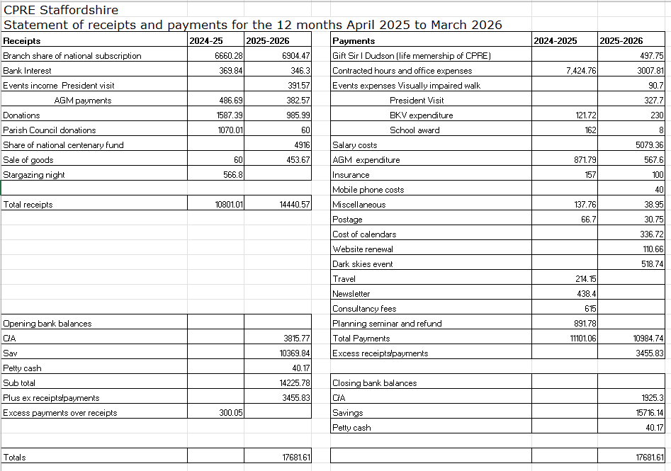

Planning Report to the 2025 AGM of CPRE Staffordshire
Paul Windmill, Volunteer Planning Advisor

This report is an up-date on the many changes made and awaited since the detailed report to the Annual Meeting last year.

National Planning Policy Framework
The New Government radically changed the NPPF in December 2024. In early 2026 it published a consultation on further revisions.

CPRE’s response included:
Green Belt Protection

As a founding champion of the Green Belt, CPRE is urging the government to uphold genuine Green Belt protection by prioritising brownfield regeneration and rejecting speculative ‘grey belt’ development. We believe new housing should only come forward through democratically agreed local plans, not via loopholes tied to arbitrary targets in the government’s standard-method housing algorithm. With three-quarters of the public calling for stronger countryside protections, and with urban brownfield land capable of providing up to 1.4 million homes, there is no justification for weakening Green Belt policy or introducing automatic development zones around train stations outside existing urban areas.
1. Green Belt policy must uphold openness, permanence, and the policy’s purposes
Several proposed changes (GB6 and GB7) weaken the tests for inappropriate development and risk normalising Green Belt loss. CPRE argues these changes contradict the NPPF’s own stated Green Belt purposes of preventing urban sprawl and keeping land permanently open.

2. The ‘grey belt’ policy is undermining the Green Belt and should be scrapped
CPRE evidence shows the grey belt policy is being used to release greenfield land, including local wildlife sites and farmland with high quality soils, and not degraded sites as promised. This has fuelled speculative development, confusion, and the “greying” of precious Green Belt land. CPRE calls for the policy to be removed entirely, or at minimum, tightly restricted and only identified through spatial development strategies.

3. Development near rural railway stations threatens openness and increases car use
Policies allowing more development simply because land is near a station (GB3 and GB7h) would lead to suburban sprawl, ribbon development, and higher car dependency, especially around isolated rural stations lacking services. CPRE supports development near urban stations on brownfield land, not rural Green Belt land.

4. Viability assessments must not become a loophole for Green Belt development
Developers frequently use viability arguments to reduce affordable housing or infrastructure contributions. CPRE warns that allowing viability assessments on so-called ‘grey belt’ sites risks undermining the government’s golden rules for this kind of development, which so far have not been fully tested.
Valued Landscapes
CPRE welcomes the draft NPPF’s stronger protections for hedgerows and trees, as well as its intention to focus development within existing settlements. But since 2012 our ‘ordinary’ countryside has been increasingly exposed to sprawling, poor-quality greenfield development driven by unrealistically high housing targets. Between August 2020 and August 2022, for example, over 140 major greenfield housing developments were allowed on appeal over the heads of local authorities. and the new draft NPPF still offer developers too many ways around local controls. We are especially concerned by the removal of the “valued landscapes” policy, which has long helped local authorities defend much-loved rural areas from unnecessary loss. CPRE believes that all rural landscapes, not only those with national designations, are valued by the communities who depend on them and must be protected accordingly.
Following the closure of the consultation in March Government said that the new NPPF would be published in the summer – at the time of writing (August 2026) it as still awaited.
More detail in https://www.cpre.org.uk/news/a-summary-of-cpres-response-to-the-nppf-consultation/

In March 2016 Government published the first “Land Use Framework”

Said to be a plan “for delivering new homes, nature restoration, clean energy and food security. It demonstrates clearly that there is enough land to deliver the government’s objectives provided we use land more efficiently and for multiple benefits.
For too long, fragmented decision-making has led to inefficient land use and left us exposed in the short term and vulnerable to climate change. Three of the five worst harvests on record were in the last five years and a third of our farmland is now at high risk of flooding.
Based on the most advanced land use analysis ever undertaken, the Framework will support food security and national resilience, making a clear, long-term commitment to maintaining food production in England. At the same time, it will also support farmers to diversify and remain profitable in the face of extreme weather and market shocks.
Farmers, who have just experienced one of the wettest winters on record, will benefit from sophisticated new modelling to help them future-proof their businesses. The Framework sets out how incentives will be optimised to deliver for nature and resilient food production. It will also give more rights and greater certainty to tenant farmers, who manage a third of England’s farmland, by reforming the Farm Tenancy Forum to give them a greater role in policy making.
The Framework gives the long-term clarity needed to meet our environmental commitments and the policy to back it up, with a single spatial map of England’s natural assets showing where nature recovery can have the greatest impact. This means by 2030, we will see restored peatlands, healthier coastal habitats, expanded wetlands, and canopy cover lining our urban streets.
For families waiting on a new home, the Framework will help steer development to the most suitable locations, away from flood plains – helping to accelerate delivery of the government’s promise of 1.5 million new homes while protecting critical habitats.”
CPRE said:-
Demands on our finite supply of land have never been more acute, with 1.5 million new homes to build, renewable energy targets to hit, nature in freefall and food security under pressure, every hectare is being pulled in multiple directions at once.
The issue is not a lack of policy tools. Six strategic mechanisms, including Spatial Development Strategies, Local Nature Recovery Strategies and the Climate Adaptation Reporting Power, that already exist and could enable smarter, joined-up decisions to be made about land use.
The challenge is that they are being used in silos. Each mechanism has been developed through the lens of a different government department, producing a patchwork of strategies that overlap, contradict and occasionally cancel each other out.
The government’s long-awaited Land Use Framework is unlikely to be the silver bullet many are hoping for. Competing departmental priorities will persist and the fundamental questions will remain unanswered: where should 1.5 million homes go? Which land is best suited to food production, and which to nature recovery or renewable energy?
Of the six tools examined, Spatial Development Strategies – which will be introduced as part of the English Devolution Bill – emerge as the most promising. They have the potential to balance housing need alongside climate, nature and food priorities but risk being treated simply as a means of distributing housebuilding targets.
With major planning consultations open and the Devolution Bill progressing through Parliament, CPRE is calling on the government to establish a statutory national plan for land use, develop a spatial framework that integrates all major sectors, and support Strategic Authorities to deliver on climate and nature targets alongside housing.
Full detail in https://www.cpre.org.uk/wp-content/uploads/2026/03/Understanding-the-tools-for-integrating-land-use-decision-making-1.pdf
In May Government published a Policy Paper
‘The Land Use Framework for England’

The Rt Hon Emma Reynolds MP Secretary of State for Environment, Food & Rural Affairs said “… England’s first ever Land Use Framework sets out a coherent national vision for how we use our land, backed by the most advanced spatial analysis ever undertaken in this country. It demonstrates clearly that we have enough land to build the homes needed to address the housing crisis, maintain domestic food production, restore nature at scale, and build clean, homegrown power to provide energy security. These are not competing demands. With the right data, the right tools, and the strategic direction this Framework provides, they are complementary ones.
To date, many of these challenges have been addressed in isolation, leading to a confused picture and missed opportunities for land to deliver multiple benefits. However, we can bring an end to this fragmented approach. We can plant trees to reduce flood risk to homes and farmland, locate energy infrastructure alongside nature-rich food production and ensure nature recovery is at the heart of resilient growth and development.
No one understands the connection between land and resilience better than the farmers who work it. They see the impact of declining pollinators, worsening soil health, birds disappearing from their fields and the rising frequency and severity of flooding. These challenges can be addressed for the benefit of our national security, farm businesses and ecosystem health.
This Framework makes a clear, long-term commitment to maintain overall food production in England, to underpin our future food security and drive economic growth. It sets out how we will safeguard our most productive land and give every farmer, whether owner or tenant, the rights, data and certainty to invest with confidence.
This is not a document that tells people what to do with their land, nor a replacement for the planning system. It is a blueprint for smarter, more informed decisions and shares cutting-edge data with those who need it most. It will speed up house building and infrastructure delivery, support farm business diversification and profitability, and accelerate the recovery of our environment.
The landscapes we know and love have always evolved. How they change next is in our hands. Today, for the first time, we have a framework worthy of that responsibility. …”
Full detail in https://www.gov.uk/government/publications/land-use-framework/the-land-use-framework-for-england-accessible

CPRE relevant report https://www.cpre.org.uk/wp-content/uploads/2025/08/Grounded-Insight-CPRE-Integrating-Land-Use-Review.pdf

Local Government Reorganisation in Staffordshire
The government has decided that two new councils will cover Staffordshire and Stoke-on-Trent in the future.
The government decision will see:
- A new unitary council covering the north of Staffordshire including Newcastle-under-Lyme, Stoke-on-Trent and Staffordshire Moorlands. This is 494,803 people.
- A new unitary council covering the south of Staffordshire including Stafford, East Staffordshire, Cannock Chase, Lichfield, Tamworth, and South Staffordshire. This is 682,775 people.
The new unitary councils will make use of the existing district, borough and city council boundaries.
This decision follows the submission of five proposals by councils in November 2025, followed by a public consultation which ran from 5 February to 26 March.
Under the government’s timetable, the new councils are expected to be established in April 2028, with elections to shadow councils held in May 2027.
The two new unitary councils will replace Staffordshire and Stoke-on-Trent’s ten existing county, city, district and borough councils.
Planning consequences:- It is certain that there will only be two Planning Authorities in Staffordshire in 2028. The existing six Local Plans in the south of the County will be replaced by one Local Plan with another, single, plan replacing the three Local Plans in the north.
Current and forthcoming Local Plans
Following their Examinations and Inspectors Reports, Cannock Chase and Newcastle-under-Lyme have now adopted their Local Plans. Stoke-on-Trent is doing its final consultation currently and I would expect it to be submitted for Examination before the end of the year to avoid having to start again.
Future Local Plans
Government has radically changed the requirements for Local Plans . England's new statutory local plan-making system officially came into force on 25 March 2026 under the Levelling Up and Regeneration Act 2023. It introduces a mandatory 30-month preparation timeline, replaces the old "duty to cooperate" with streamlined processes, and uses three formal assessment gateways..

Core Features of the New System
The current processes and requirements are largely unchanged procedurally and it is very difficult to believe that the majority of local authorities will be meet the 30 month deadline.
Several Councils have produced Scoping Reports for public consultation but consideration does not appear to have been given to the effect of the re-organisation of all of the Councils and the impact on Local Plans.
Under the Government’s proposals all of the existing Councils in Staffordshire will cease to exist in April 2028 but each is apparently proceeding to prepare an individual local plan for their area but which cannot be completed, examined and adopted before the Councils cease to exist.
It would seem more logical for the existing Councils to now prepare a Joint Plan which could proceed and become the new Local Plan for the combined Councils. There is already a straightforward power for Councils to prepare Joint Local Plans - yet so far there is no evidence of co-operation in plan preparation between any of the merging existing Councils either in the north or south of the County.

The Planning and Infrastructure Act

CPRE’s views
We’ve been calling on the government to protect and regenerate the countryside, protect local democracy, and encourage the sustainable use of land, particularly through recycling brownfield land – previously developed land that’s no longer being used – for homes and infrastructure.
Spatial Development Strategies
The Act creates new long-term plans for how development will happen across larger areas of the country, something we have supported for a long time. We believe these new spatial development strategies (SDS) will improve how we deliver housing in the countryside, while protecting nature and green space. CPRE supported amendments to ensure these plans prioritise the use of brownfield land, but despite the House of Lords backing these changes, the government removed them. This is a disappointing setback for nature, local democracy and responsible land use. But our campaigning continues. We will have more opportunities to be a strong voice for the countryside in the new year with the government expected to launch a consultation on further changes to national planning policy soon.
Environmental Delivery Plans
Through the Planning and Infrastructure Act the government has introduced Environmental Delivery Plans (EDPs) to change how developers protect and enhance our environment when building. We think these plans will encourage developers to damage the environment locally and simply ‘make up for it miles away. That’s not restoration — it’s displacement. This could also mean that some people lose access the local green space. We were pleased when the government made some changes due to pressure from CPRE and our partners in the environmental sector, and with our allies we will continue to hold the government to account on environmental protection.
National Parks and National Landscapes duty
in the last round of planning changes in 2023, the Conservatives strengthened the law for National Parks and National Landscapes (formerly AONBs) giving public bodies a legal duty to enhance the purposes of protected landscapes. CPRE were delighted when this was made law.
However, the government now wants to water down this commitment or scrap it entirely, despite Labour supporting it in 2023. We will be working with the Campaign for National Parks, the National Landscapes and other environmental charities to defend this duty – ensuring we continue to improve our natural environment, wildlife and heritage.
Keeping environmental protections
Since taking office, the government has tried to pin the blame for slow development on environmental protections. But good rules don’t block good homes – they stop poor-quality schemes and protect the countryside, nature and landscapes every community depends on. The real barriers to delivery lie elsewhere: market failure, land banking, and a lack of genuinely affordable homes.
The Environmental Improvement Plan sets out welcome ambitions for restoring nature. But ambition only matters if government policy pulls in the same direction. Protecting landscapes and speeding up sensible development are entirely compatible – and ministers need to stop pretending they’re in conflict.
That’s why the recent review calling for weaker environmental protections for new nuclear infrastructure is so troubling. And the Prime Minister’s pledge to slash so-called ‘red tape’ across the board cuts directly against the goals in the EIP. Diluting safeguards won’t build better places; it will simply lower standards. CPRE will keep pressing for a planning system that delivers the homes we need and regenerates the nature and landscapes that sustain us.
More information:- https://www.cpre.org.uk/explainer/the-planning-infrastructure-act-what-does-it-do-and-what-happens-next/

Spatial Development Strategies
In a very long and detailed letter dated 12 February to all Chief Executives the Ministers set out in some detail their intentions for Regional Spatial Strategies (Extracts only below)
The Planning and Infrastructure Act 2025 reinstates a strategic planning system for England. Once the provisions in the Act are commenced – which is expected by the summer – places will be required to produce an SDS. These strategies will deal with strategic and cross-boundary issues and set the context for local plans, which will have to be in ‘general conformity’ with the umbrella SDS once adopted. By taking a sub-regional view of how growth needs can be sustainably met, they will help us build more homes, co-ordinate the delivery of strategic infrastructure, grow the economy, and improve the environment and climate resilience. We strongly believe that strategic planning, as just one part of the growth equation, is most effective when done over devolution geographies.
…In other places, we do not believe there is a consensus view yet, and so we are seeking proposals from you that align with the ‘sensible geography’ criteria in the White Paper…
…Where SDSs are not coterminous with Strategic Authorities, the formal mechanism for areas to work together on their SDS will be a Strategic Planning Board (SPB), which will be established through secondary legislation…
For parts of the country currently without mayoral devolution, we have set out that SDSs need to be developed across ‘sensible geographies’ in line with the principles of the English Devolution White Paper. .. In some places, there is already broad agreement on them, and we have indicated these in the consultation. In other places, we do not believe there is a consensus view yet…
…The government remains firmly committed to mayoral devolution and is forging ahead with it – including through our Devolution Priority Programme – but we have been clear that this model works best when built on firm foundations. This includes the strong unitary structures we are creating through local government reorganisation, and we remain fully committed to delivering these important reforms within this Parliament to the timetable set out….
The Planning Advisory Service (part of the Local Government Association) thinks that:-
It is intended for SDSs to be concise, with a clear focus on strategic matters.
Their primary purpose is to guide sustainable growth and address key cross-boundary spatial issues - including setting and distributing housing need figures, enabling the delivery of strategic infrastructure, supporting economic growth across functional geographies, and improving climate resilience.
SDSs will also be expected to help deliver Local Growth Plans and Local Nature Recovery Strategies, aligning strategic planning with strategic economic and environmental priorities.
SDSs will not include site allocations on an Ordnance Survey base – they can however identify broad locations for growth/development.
SDS will need to be supported by evidence. They will be subject to consultation and examination.
(Extracts from https://www.local.gov.uk/pas/plans/strategic-planning
What will happen in Staffordshire?
It is unclear whether there will be a SDS covering the West Midlands Combined Authority together with the new Authorities in Staffordshire, Worcestershire and Warwickshire – but it seems unlikely.
CPRE views
Environmental Delivery Plans & Spatial Development Strategies
While CPRE did not support the introduction of EDP’s, now that they are law it is critical that CPRE works locally to shape how they work in practice, along with new SDS.
When developers and the government start using both new tools, they will need to be approved and should involve consultation, so CPRE’s local groups across the country will work to ensure they protect and regenerate the countryside, landscapes and nature.
Keeping environmental protections
Since taking office, the government has tried to pin the blame for slow development on environmental protections. But good rules don’t block good homes – they stop poor-quality schemes and protect the countryside, nature and landscapes every community depends on. The real barriers to delivery lie elsewhere: market failure, land banking, and a lack of genuinely affordable homes.
The Environmental Improvement Plan sets out welcome ambitions for restoring nature. But ambition only matters if government policy pulls in the same direction. Protecting landscapes and speeding up sensible development are entirely compatible – and ministers need to stop pretending they’re in conflict.
That’s why the recent review calling for weaker environmental protections for new nuclear infrastructure is so troubling. And the Prime Minister’s pledge to slash so-called ‘red tape’ across the board cuts directly against the goals in the EIP. Diluting safeguards won’t build better places; it will simply lower standards. CPRE will keep pressing for a planning system that delivers the homes we need and regenerates the nature and landscapes that sustain us.
More information:- https://www.cpre.org.uk/explainer/the-planning-infrastructure-act-what-does-it-do-and-what-happens-next/

National Scheme of Delegation for Planning Decisions
MHCLG have laid draft regulations in Parliament on 1st June that will, subject to Parliamentary approval, introduce a national scheme of delegation for planning decisions across England. They place planning applications into two categories:
• Schedule 1: those which must always be delegated to planning officers for a decision; The types of applications in Schedule 1 which must be determined by an officer include applications for minor residential and commercial development, householder development, discharge of condition applications and reserved matters applications for proposals, where the outline is below 500 dwellings.
• Schedule 2: those which are presumed to be delegated to officers but which, in certain defined circumstances (known as the gateway test), can be considered by planning committees include larger applications for planning permission not sent out in Schedule 1, reserved matters applications where the outline is above 500 dwellings, and applications for listed building consent.
The Gateway Test to take Schedule 2 applications to committee requires the nominated officer (usually the chief planner or equivalent) and the nominated member (usually the chair of the committee) to agree that the application meets one of the following criteria:
• A. where the application raises an economic, social or environmental issue of significance to the local area
• B. where the application raises a significant planning matter having regard to the development plan and any other material considerations There are separate provisions allowing the committee to consider applications linked to the local planning authority for propriety reasons where they do not need to meet the Gateway Test.
The Regulations also set a maximum cap on the size of planning committees of 13 members. The draft Regulations must first be considered by Parliament. Following that, if approved the final version will be laid and they will come into effect on 31 October 2026.
CPRE views
The government wants to introduce a National Scheme of Delegation that would take key planning decisions out of the hands of local councillors and give them to planning officers by default. Ministers argue this will stop local committees from rejecting housing schemes. But the real blockers are the handful of big housebuilders who control land, slow down build-out rates, and drip-feed supply to protect profits.
CPRE is pushing back against this. Centralising these decisions waters-down local democracy, making it harder for local communities to have a say about what gets build where they live. It risks shifting decisions away from open, democratic committees and into processes that people can’t easily challenge or influence. We’re always working to ensure communities keep a meaningful voice in shaping development in their area.
CPRE secured a win on the National Scheme of Delegation, with the government promising a vote in parliament on the specific plans for which decisions should and shouldn’t go to local planning committees. When that vote happens, CPRE will work hard to engage MPs on how to stop the loss of community voices.
The effect?
Ironically, the national scheme of delegation it is likely to make decision making on the ground more complex and more controversial as the public adjust to their elected representatives being excluded from decision making. While all this effort is dedicated to curbing democratic oversight rather than rebuilding the trust and goodwill. so important to the future resilience of our communities remains undone.

Paul Windmill
13 August 2026

Planning round-up
Over the past 12 months, we have responded to 14 planning applications and counting. Of the planning applications, 10 were for housing development and 3 for solar farms or battery storage facilities. We would like to thank our volunteers who review and respond to these applications for their hard work and dedication.

South Staffordshire
25/00686/OUTM
Outline planning application (with all matters reserved except primary means of vehicular access from Brewood Road) for the construction of up to 150 dwellings, associated access, drainage, green and blue infrastructure, ground remodeling, and ancillary infrastructure.
Land At Grange Farm School Lane Coven Awaiting Decision
CPRE Staffordshire objected due to location within green belt, village growth and settlement hierarchy and infrastructure capacity.

25/00874/OUTM
Outline planning for up to 550 residential dwellings, land for an 80 unit extra care facility, land for a community shop, land for an electric vehicle car club, associated access, infrastructure, open space, landscaping and drainage.
Land At Heath House Lane Codsall. Awaiting Decision
CPRE Staffordshire urged the council to defer determination pending the outcome of the Local Plan examination.

26/00283/OUTM
Outline Planning Application, with all matters reserved except access, for up to 115 residential dwellings, public open space, landscaping, sustainable drainage and all associated works
Land North of B4176 Bridgnorth Road, Himley Awaiting Decision
CPRE Staffordshire opposes the proposed development due to its potential harm to the Green Belt and the rural character of Himley.

Staffordshire Moorlands
SMD/2025/0385
Proposed change of use of existing barns building, Menage and Land area shown edged red on the enclosed application plans, together with new vehicle access, gateway and hardstanding constructions with vehicle turning and car parking areas and tree planting, to form a Landscape Stone Products Retail and Trade Supply Business, to be known as Higherland Stone.
Caverswall, Staffordshire, ST11 9EU Planning Permission – Refused

Lichfield
25/00985/OUTMEI
Outline planning application for up to 500 dwellings (all reserved matters except for a new access onto Hay End Lane), new sports provision consisting of playing fields, sports pavilion and associated parking, new open space, land for a new primary school, sustainable drainage, new ecology areas and woodland, landscaping and associated works.
Land North Of Hay End Lane Fradley Pending Consideration
CPRE Staffordshire objected to this application as it represents inappropriate and unsustainable form of development that conflicts with both national and local planning policy

25/01221/FULM
Installation of a Battery Energy Storage System (BESS) including associated infrastructure and landscaping.
Rugeley Road Armitage Rugeley Pending Consideration
CPRE Staffordshire objected to this proposal as it presents a combination of significant environmental, safety, heritage and amenity harms that cannot be justified in this sensitive location.

26/00016/OUT
Outline application for the erection of up to 4 No. dwellings, with all other matters reserved (except access).
Wyndfield Walsall Road Pipehill Appeal lodged

26/00425/OUTM
Outline planning application (with all matters reserved apart from access) for the demolition of the dwellinghouse known as Priors, the provision of up to 100 dwellings (Use Class C3) and associated infrastructure including but not limited to new access road, sustainable urban drainage systems, public open space, landscaping, child play space, shop; and appropriate boundary treatment to the railway.
Little Aston Sutton Coldfield Staffordshire Refused
CPRE Staffordshire objected to the application as the proposal constitutes inappropriate development within the Green Belt and would result in the permanent and irreversible loss of open countryside, Best and Most Versatile agricultural land, mature trees, priority habitats and functional ecological networks.

Stafford
25/40876/FUL
Cotes Heath Solar - installation of up to 15MW solar farm with associated infrastructure (panels, inverters/transformers, substation, access, landscaping)
Cotes Heath, Stafford Awaiting decision
CPRE Staffordshire objected to this application due to Loss of Best and Most Versatile Agricultural Land, flood risk, highways and construction disruption and Biodiversity Net Gain – Metric Failure and Uncertainty.

25/41516/OUT
Outline planning application with all matters reserved (except for principal means of access), for development comprising up to 480 residential dwellings (Use Class C3), specialist housing for older people (Use Class C2 or C3), medical centre/primary care hub (Use Class E) and primary school (Use Class F.1), with associated open space, landscaping and other associated works including infrastructure, earthworks and drainage
North Of Stafford Road Eccleshall Stafford Awaiting decision
CPRE Staffordshire urges the council to defer the determination of this application pending the preparation and adoption of the new local plan.

25/40683/OUT
Outline planning application for up to 100 dwellings, open space and associated infrastructure (all matters reserved except for means of access)
Land Off Dickys Lane Woodseaves Stafford Staffordshire Awaiting decision
CPRE Staffordshire objected to this application as the development would introduce an industrial-scale housing estate into open countryside beyond the settlement boundary, without evidence that it responds to genuine local need.

25/41179/OUT
Outline planning application (with all matters reserved for future determination except for means of access) for up to 360 residential dwellings (Use Class C3) including public open space; access from Milford Road; landscaping; sustainable drainage systems; and associated infrastructure.
Walton On The Hill Stafford Staffordshire Awaiting decision
CPRE Staffordshire has objected to the above application: The applicant has not demonstrated as required by the NPPF that any public benefits arising from the delivery of new housing units would clearly outweigh the significant harms that would accrue. The development is not sustainable in any meaningful sense, and the presumption in favour of sustainable development at NPPF paragraph 11 does not apply given the direct conflict with specific restrictive policies, including those protecting the National Landscape.

East Staffordshire
P/2026/00548
Outline application for the erection of up to 49 dwellings and associated works, including details of access (all matters reserved except for access).
Ashbrook Lane Abbots Bromley Pending
CPRE Staffordshire respectfully submits that this application should be refused as it does not demonstrate why this particular piece of countryside should cease to exist and fails to justify the permanent extension of the village into this particular part of its rural setting.

Stoke-On-Trent
Stoke-on-Trent City Council has produced the Draft Local Plan to guide the future development of Stoke-on-Trent. The Local Plan sets out how much development should happen over the plan period of 2020-2040 and where it will go. It will ensure that long-term policies are in place to manage and meet the needs of local people and businesses for employment, housing, green space and supporting services.
CPRE Staffordshire has provided comments on this Draft Local Plan, with concerns around development on Greenfield land.

