Enter now to win the 2026 Green Schools Trophy for your school!

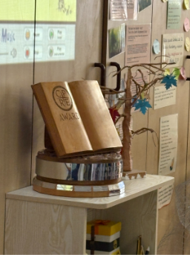
All Staffordshire schools are invited to showcase their conservation and environmental projects for a chance to win a micro-pond workshop and hold the trophy for a year.
We are looking for inspiring projects that contribute to the protection, conservation, or improvement of the local environment. This could be through cutting down on single-use plastics, practical conservation work, creating wildlife habitats, promoting energy-saving or waste reduction/recycling, green transport schemes or any other original idea your school may come up with.

For more information on the Green Schools Trophy scheme, including examples of previous winners, visit our website: www.cprestaffordshire.org.uk/discover/green-schools-trophy/ or scan the QR code.

Key dates:
Applications Open: February 2026.
Applications Close: Friday 22nd May at 5pm.
Winners announced: June 2026.

CPRE Staffordshire is a registered charity (number 219443) that aims to protect, promote and enhance Staffordshire’s countryside and green spaces. We’re passionate about making Staffordshire's countryside a better place for everyone to live, work and enjoy.

Please use the form below to submit your bid for the 2026 CPRE Staffordshire Green Schools Trophy. The winning school will hold the trophy until the 2027 summer term.
Projects should be ongoing, started within the last 12 months, or if now complete, completed within 12 months of the closing date.
The closing date for entries is Friday 22nd May 2026 at 5:00pm and the winner will be notified in the summer term.
If you have any questions, please email protect@cprestaffordshire.org.uk.
Please email your entry to protect@cprestaffordshire.org.uk. If you require another format or access adjustments, please contact

School Name:
School Address:
School Telephone Number:
Contact Name:
Contact Email and/or Phone:

If you have previously applied in 2025 and would like to reuse your application, please tick. ☐
You may provide additional information towards your application below.

Project Description (in no more than 500 words – please provide additional attachments, photos etc. as required):

